|  |  |  |  |  |  |  |  |  |  |  |  |  |
| --- | --- | --- | --- | --- | --- | --- | --- | --- | --- | --- | --- | --- |
| |  |  | | --- | --- | | Olive Oil | Eggs | | Carrots | Onion | | Garlic | Frozen Peas | | Quinoa | Soy Sauce | | Oyster Sauce | Toasted Sesame Oil | | Salt | Pepper |  Ingredients Without Measurements |

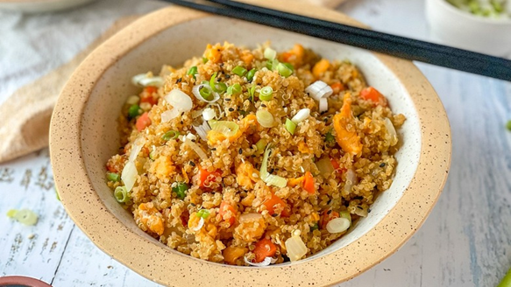Quinoa Fried Rice

|  |
| --- |
| Ingredients With Measurements  * 2 tablespoon olive oil, divided * 3 eggs, beaten * 2 medium carrots, peeled and diced * 1 small white onion, diced * 4 cloves garlic, minced * ½ cup frozen peas * 4 cups cooked quinoa * 4 tablespoon soy sauce * 2 teaspoon oyster sauce * ½ teaspoon toasted sesame oil * Salt * Pepper |

|  |
| --- |
| Recipe Heat 1 tablespoon of olive oil in a large skillet over medium heat.  Add the beaten eggs and cook while stirring occasionally until they are scrambled and cooked through.  Transfer the scrambled eggs to a plate and set it aside.  Add the remaining 1 tablespoon of olive oil to the skillet and turn the heat to medium-high.  Add the carrot and onion and cook until softened, about 5 minutes.  Add the garlic and cook for another minute,  Add the peas and continue to cook until they are warmed through and plump, about 2 to 3 minutes.  Add the cooked quinoa, soy sauce, oyster sauce, and toasted sesame oil and stir to combine.  Cook for an additional 3 to 5 minutes to fry the quinoa.  Add the scrambled eggs into the mixture and mix well.  Remove from heat and serve immediately. |